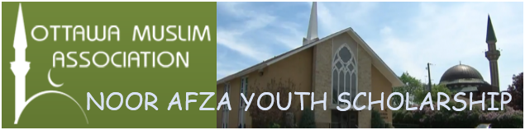
OMA will be awarding a post-secondary scholarship for the 2017/2018 academic year. Award amount will depend on the need and committee decision. These will go to the top ranked students as decided by the Selection Committee.
Areas of Study
Any acceptable Ottawa area college or university program leading to a diploma or degree is eligible. Acceptability is determined by the Selection Committee.
Eligibility
Any youth who is pursuing a full-time first degree or diploma? Immediate family members of the Selection Committee or any officials of OMA are not eligible for this award.
Application Process
To apply for the Noor Afza Youth Scholarship:
- Obtain a Noor Afza Scholarship Application Form either from OMA office or online at http://ottawamosque.ca.
- Complete Personal Information, Education (both school last attended and institution you are going to attend), and Community Volunteering (where you volunteered, what you did, number of hours volunteered, name of supervisor(s), and phone number). Include additional pages as required.
- Attach:
  - A transcript of marks for the current year of study (2015/2016/2017)
  - Proof of acceptance into the course of study this application is for
- Sign and date the Application Form and mail to:
  - Attention: Scholarship committee
  - 251 NorthWestern Ave., Ottawa, ON
- Or
  - Email - oma@ottawamosque.ca
Note: application deadline is 15 September, 2017.
The scholarships are based on the following criteria:
- Academic performance
- Financial need
- Community service

NOOR AFZA YOUTH SCHOLARSHIP APPLICATION FORM
Complete this form and mail it along with all supporting documentation to: Attention: Scholarship committee, 251 NorthWestern Ave., Ottawa, ON
email - oma@ottawamosque.ca
Academic scholarships are available only to students residing in Ottawa Carleton Region.
TYPE OR PRINT CLEARLY.
1. PERSONAL INFORMATION
Given Name (s): |  |  | Family Name:
Home Address:
Province: |  |  | Postal code:
Email address
City: |  | Phone Number:
2. EDUCATION
School last attended:
Major/Minor Subjects:
School Address:
School phone number: |  |  |  |  | School Fax number:
Educational Institute going to attend:
Program of study accepted to:

3. COMMUNITY VOLUNTEER WORK
Organization: |  |  |  |  |  | Supervisor Name:
Supervisor Phone number: |  |  |  |  |  | Number of hours:
Service provided:
Organization: |  |  |  |  |  | Supervisor Name:
Supervisor Phone number: |  |  |  |  |  | Number of hours:
Service provided:
Organization: |  |  |  |  |  | Supervisor Name:
Supervisor Phone number: |  |  |  |  |  | Number of hours:
Service provided:

Include the following documentation:
- Copy of transcript of marks showing year just completed and previous years’ marks.
- Copy of both parents Notice of Assessment for the previous two (2) taxation years.
- Proof of acceptance into the course of study this application is for.
- Attach extra pages as required.

Signature: |  | Date:
APPLICATION DEADLINE: September 15, 2017
FORM MAY BE PHOTOCOPIED. For additional information: ottawamosque.ca
Decisions by the Selection Committee are Final

