|  |  |  |
| --- | --- | --- |
| اللّهُ أكبرُ كَبيِرَا *Allahu Akbaru Kabeera* Allah is the Greatest | و لِلّه الحمدَ *walilahil Hamd* to Him belongs all Praise | ا**للّهُ أكبر اللّهُ أكبر اللّهُ اكبر** *Allahu Akbar, Allahu Akbar, Allahu Akbar* Allah is Great, Allah is Great, Allah is Great |
| لا إلَهَ الا اللّه *La illaha il Allah* there is no God, but Allah the Unique | وَ سُبحَان اللّهِ بُكرَةً وَأصْيِلا  *wa Subhan allahi bukratan wa aseila* And Glory to Allah eventide and in the morning | وَالحَمدُ لِلّهِ كَثِيرا *wal-Hamdulilahi katheera* And all Praise is due to Him |
| لا إلَهَ الا اللّه *La illaha il Allah* there is no God, But Allah | وأعزَ جُنَده وَهزم الأحْزَابَ وحْدَه *wa a'azza jundahu wa hazamal-ahzaaba wahdah* and made Mighty His soldiers and defeated the confederates | صَدَقَ وَعدَه وَنَصَرَ عبده *sadaqa wa'dah wa nasara abda* He has fulfilled His Promise and made Victorious His servant |
| اللّهمَ صَلِّ على سيْدنَا مُحَمد *Allahumma salli ala sayyedna Muhammad* O Allah, have Mercy on our Prophet Muhammad | مُخلِصِّينَ لَهُ الدّيِنَ وَلوْ كَرِهَ الكَافِروُن *mukhlessena lahud-deena walaw karehal-Kafeeroon* with sincere and exclusive devotion even though the idolaters hate it | وَلا نَعبُد الا أياه *wa laa na'budu illa iyyah* He alone we worship |
| وَعَلى أنصَارِ سيْدنَا مُحَمد *wa ala ansari sayyedna Muhammad* and on the helpers of our Prophet Muhammad | وَعَلى اصْحَابِ سيْدنَا مُحَمد *wa ala as-haabie sayyedna Muhammad* and on the companions of our Prophet Muhammad | وَعَلى آلِ سيْدنَا مُحَمد *wa ala aalie sayyedna Muhammad* and on the family of our Prophet Muhammad |
| وَ سَلّم تَسْلِيماَ كَثّيرا *wa sallim tasleeman katheera* and Bestow upon them much peace. | وَعَلى ذُرِّيَةِ سيْدنَا مُحَمد  *wa ala dhurreyatie sayyedna Muhammad* and on the progeny of our Prophet Muhammad | وَعَلى أزوَاجِ سيْدنَا مُحَمد *wa ala azwajie sayyedna Muhammad* and on the wives of our Prophet Muhammad |

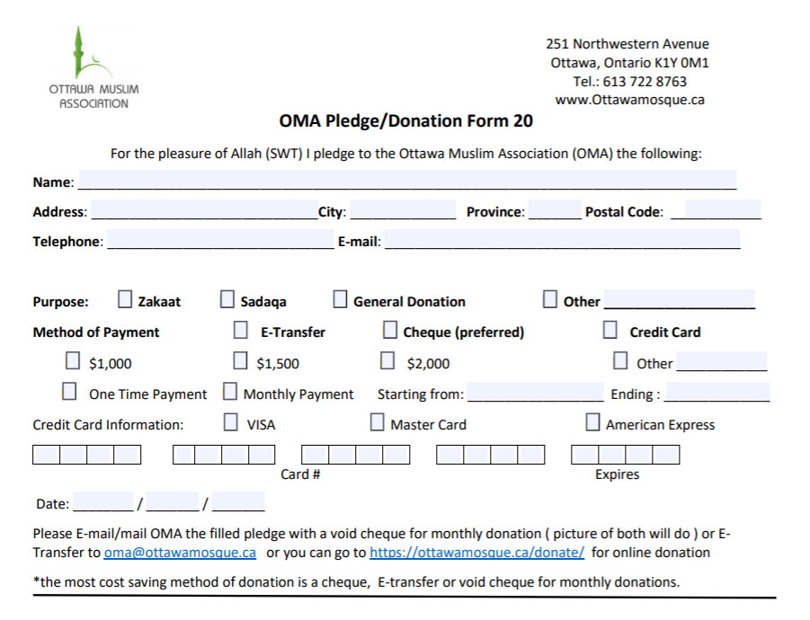

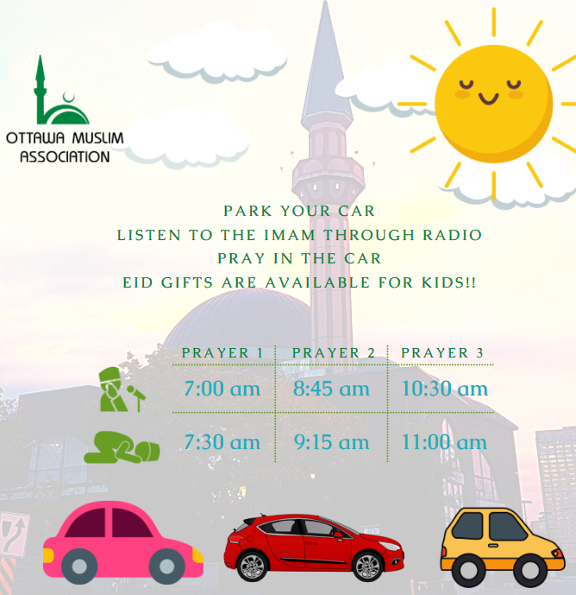

**Eid Al-Fitr Prayer Instruction**

The Eid celebration is OUTDOOR ONLY, The prayer will be inside your car ( Drive-in) and in the Parking lot.

* The whole family is welcome, there is no Age limit, Due to the pandemic , washroom and mosque will be closed. Come prepared.
* Stay inside your car all the time and follow the volunteer’s instructions.
* Tune in your car radio to FM channel 97.5
* There will be **loot bags** for the children ( Eid Gifts)
* You will be able to leave the parking lot after the Khotbah (Sermon) is completed.
* When the prayer and sermon are completed, please wait for the Volunteers to usher you to the exit in an orderly fashion.
* Car with the best decoration will receive a gift